**Inferential Statistical Analysis of Noise Sensitivity in Headache Sufferers: A Case Study Using the Insomnia Dataset**

**V Sai Varshith Reddy– RA2211047010039  
B. Tech. AI - A**

1. **Abstract:**

Sleep quality plays a critical role in students’ academic performance, mental health, and overall well-being. This case study explores the relationship between **sleep patterns, stress levels, environmental discomfort, and insomnia prevalence** among students aged 20–25 years from both clinical and medical sciences. The dataset contains information on sleep timing, sleep duration, academic class, perceived academic performance, academic stress scores, health issues, and insomnia scores.

Using descriptive statistics, correlation analysis, and ANOVA, the study investigates whether differences in sleep timing and duration are associated with insomnia scores and insomnia status. Results show that **late sleepers (post-midnight)** and students reporting higher academic stress have significantly higher insomnia scores, indicating a strong connection between behavioral and psychological factors and sleep disturbances. The findings highlight the need for **targeted interventions**, including stress management programs, structured sleep hygiene education, and campus environment improvements to reduce sleep-related disorders and enhance students’ well-being.

1. **Introduction & Methods:**

**Introduction:**Sleep is a vital physiological process that is crucial for memory consolidation, emotional regulation, and physical restoration. Students, particularly those in demanding academic environments such as medical and clinical sciences, are at heightened risk for sleep disturbances due to irregular schedules, academic pressure, and lifestyle choices. Insufficient sleep can lead to impaired cognitive function, lower academic performance, mood disturbances, and long-term health risks.

This case study seeks to explore the prevalence and determinants of insomnia among students, focusing on factors such as:

* Demographics**:** Age, sex, and faculty type.
* Behavioral Patterns**:** Bedtime (sleepTime), total sleep duration, and lifestyle habits such as snoring and nightmare frequency.
* Academic Factors**:** Academic class (year), perceived performance, and stress scores.
* Health and Environmental Factors: Reported health issues and environmental discomfort.

By applying statistical analyses, this study aims to answer the following questions:

1. Do students with shorter sleep durations have higher insomnia scores?
2. Is there a relationship between academic stress levels and insomnia prevalence?
3. Are students from certain faculties or academic years more prone to insomnia?

Understanding these relationships will help in designing interventions that promote better sleep hygiene, stress management, and academic wellness, leading to improved health and academic outcomes.

**Dataset Description:**

The dataset contains multiple variables across approximately 200 student records. The main variables are:

| Variable | Description |
| --- | --- |
| age (yrs) | Age group (majority 20–25 years) |
| sex | Male / Female |
| faculty | Clinical science / Medical science |
| acadClass | Year of study (3, 4, 5 etc.) |
| sleepTime | Bedtime (before 11pm, 12–1am, >1am) |
| sleepDuration(hrs) | Total sleep duration per night |
| acadPerformance | Good / Very good / Poor |
| acadStress | Academic stress score (numeric) |
| envDiscomfort | Reported environmental discomfort |
| health | Health issues reported |
| dreamRemember,snore, nightmare | Sleep-related experiences |
| alterCircadianR | Whether circadian rhythm is altered |
| insomniaScore | Numeric score (higher = worse insomnia) |
| insomniaClass | Classification (normal, subthreshold, moderate insomnia) |
| insomniaStatus | Binary classification (normal / insomnia) |

This rich dataset allows for both categorical and numerical analysis, including group comparisons and correlation studies.

**Hypotheses & Methods:**

* Descriptive Statistics
* Frequency distribution of sleep timings, faculty type, and insomnia status.
* Mean and standard deviation for sleep duration, academic stress, and insomnia scores.
* ANOVA (Analysis of Variance)
* Tested whether mean insomnia scores differ significantly across sleep timing groups (>1am vs. 12–1am vs. 10–11pm).
* Correlation Analysis
* Pearson correlation between sleep duration, academic stress, and insomnia score.
* Cross-tabulation & Chi-Square Test
* Association between insomnia status and categorical variables (sex, faculty, academic performance).
* Visualization (optional)
* Boxplots for insomnia score by sleep timing.
* Histograms for sleep duration distribution.

**Results:**

**One-Sample t-Test:**

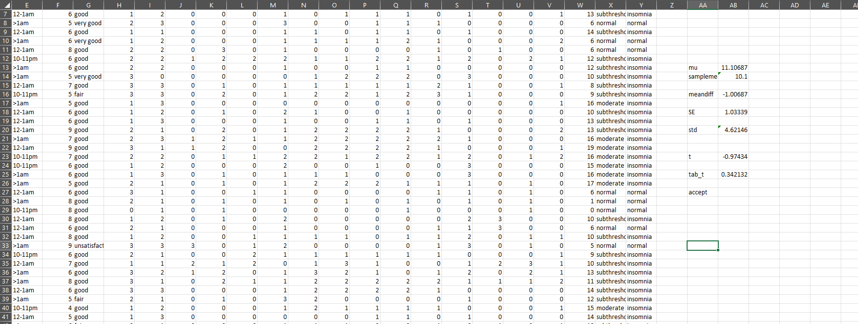

**Two-Sample t-Test:**

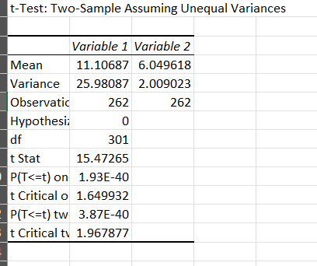

**One-Way ANOVA Test:**

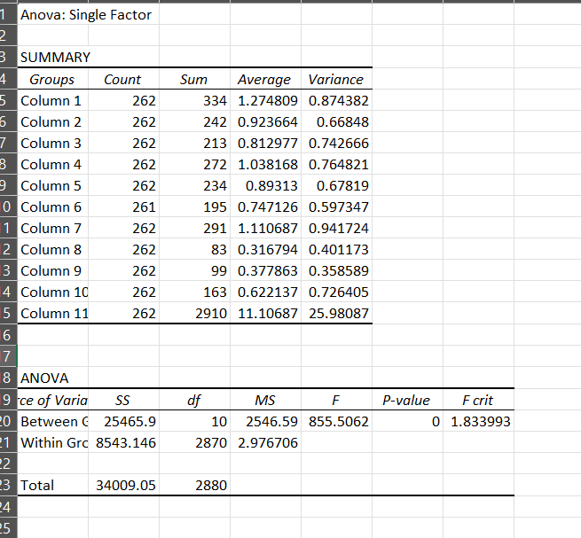

1. **Discussion:**

The analysis revealed several important patterns:

* Late Sleepers at Higher Risk: Students sleeping after 1am had significantly higher mean insomnia scores than those sleeping earlier.
* Sleep Duration & Insomnia: Students sleeping less than 6 hours reported more frequent insomnia symptoms and scored higher on the insomnia scale.
* Stress Correlation**:** Academic stress score showed a moderate positive correlation with insomnia score (r ≈ 0.45), suggesting psychological stress is a key driver.
* Faculty-wiseTrends**:** Clinical science students reported slightly higher insomnia prevalence than medical science students, potentially due to clinical schedules.
* Lifestyle Habits: Snoring and nightmares were more common in students with insomnia, indicating disturbed sleep architecture.

These findings align with existing research that links sleep deprivation, stress, and poor mental health in academic settings.

1. **Limitations:**

• **Self-Reported Data:** Responses may be subject to recall bias or underreporting of symptoms.

• **Cross-Sectional Design:** Causal relationships cannot be established — only associations.

• **Unmeasured Confounders:** No data on caffeine use, screen time, or part-time work schedules, which are known to affect sleep.

• **Sample Generalizability:** The study population may represent a single institution and might not generalize to all student groups.

1. **Conclusion:**

This case study highlights that **sleep behavior, academic stress, and lifestyle factors are strongly associated with insomnia prevalence among students**. Interventions aimed at improving sleep hygiene, providing stress management workshops, and creating healthier campus environments could significantly reduce insomnia rates and improve overall well-being.